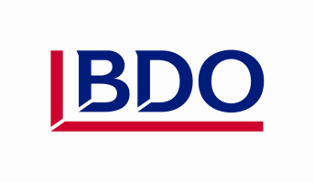

BDO Gazebo Application Form
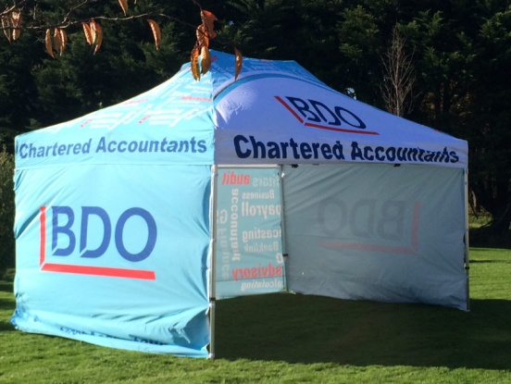

Name of Business

Contact Person

Phone

Email

Dates Required

Event Gazebo will be used for

BDO Chartered Accountants Invercargill
136 Spey Street
INVERCARGILL
Application Approved

